ACS221 –Control System Design Assignment

# Question 1

**A unity feedback servo system has a plant with the transfer function given by:**

$$G(s) =\frac{5000}{s(s+0.3)(s+22)(s+100)}$$

**Question A: Using the frequency domain approach, determine the gain K required to give an  
overshoot, in response to a step input, of approximately 20%. Explain how you  
achieved your result.**

**The plant is a third order system which has 82.86% overshoot with unity feedback, and the target is to lower the overshoot to 20%.**

**To get the 20% overshoot, the following equations will be used during the calculation, the maximum overshoot can be obtained by setting $Omax$ to get**  by using Equation 1, and then work out the phase margin using the equation 2, and use the bode diagram to find out the gain crossover frequency for that phase margin. Then use the property of the |K*G(jw)|= 0dB=1, plug in the ω inside the equation to work out the K. And the K is required proportional gain compensator.



Equation 1: Overshoot/safety factor of plant’s damping ratio



Equation 2: Phase Margin of current plant by damping ratio

In practical, the $Omax$ **is considered a bit lower than the requirement, in this case, it was set to 14% overshoot, which is 0.14 in equivalent of $Omax$,**



Equation 3: damping ratio of chosen overshoot

And the phase margin will be:



Equation 4 calculated phase margin

Therefore the gain crossover frequency is located at phase angle -180+48.73, which is -131.27. The frequency can be worked out by following calculation

$$-90-\tan^{-1}\left(\frac{ω}{0.3}\right)-\tan^{-1}\left(\frac{ω}{22}\right)-\tan^{-1}\left(\frac{ω}{100}\right)=-131.27$$

Equation 5: Interpretation of desired gain crossover frequency

$$\tan^{-1}\left(\frac{\frac{ω}{0.3}+\frac{ω}{22}}{1-\frac{ω*ω}{0.222}}\right)+\tan^{-1}\left(\frac{ω}{100}\right)=41.27$$

$$\tan^{-1}\left(\frac{\frac{22.3ω}{6.6-ω^{2}}}{1-\frac{223ω}{6.6-ω^{2}}×\frac{ω}{100}}\right)=41.27$$

$$\tan^{-1}\left(\frac{2230ω+ω\left(6.6-ω^{2}\right)}{660-100ω^{2}-22.3ω^{2}}\right)=41.27$$

$$\frac{2230ω+ω\left(6.6-ω^{2}\right)}{660-100ω^{2}-22.3ω^{2}}=0.878$$

$$ω=0.25$$

Equation 6: Calculation of ω

$$\left|G\left(jw\right)\right|*k=1$$

Equation 7: Finding k using known magnitude at gain crossover frequency

$$k*\left|\frac{5000}{0.25j*\left(0.25j+0.3\right)*\left(0.25j+22\right)*\left(0.25j+100\right)}\right|=1$$

$$\left|G\left(jω\right)\right|=23.28$$

$$k=\frac{1}{G|jω|}=0.043$$

Equation 8: Continued calculation to work out k

The response of the plant with calculated k compensator shown below using

$$G\left(s\right)=\frac{5000*0.043}{s\left(s+0.3\right)\left(s+22\right)\left(s+100\right)}=\frac{215}{s\left(s+0.3\right)\left(s+22\right)\left(s+100\right)}$$

Equation 9

To verify the new plant in MATLAB, by using following step

G=zpk([],[0 -0.3 -22 -100],[5000]);

k=0.043;

Gk=G*k;

Gkc=feedback(Gk,1);

Step(Gkc)

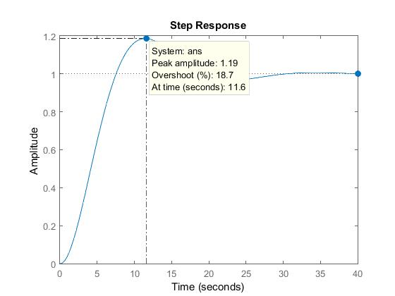

Figure 1

The peak overshoot with K=0.043 is 18.7%. It is close to required 20% with less than 10% error.

**B. Using frequency domain approach, design a lead compensator to achieve a  
velocity error constant that is at least 35 and a step response overshoot that is  
no greater than 20%. Describe each stage of your design. If performance  
specifications are not met first time, perform additional design iterations (i.e.  
refine the lead compensator or design additional compensators/pre-filter).  
Write down the final compensated open- and closed-loop transfer functions and  
use MATLAB to evaluate the performance of your final design in the time and  
frequency domain.  
Use MATLAB to plot the response of the control system to a unit ramp, showing  
both system output and ramp input, and evaluate the percentage steady state  
error to the ramp input signal.  
Summarize the performance indices of your final design in a table – see Table 1 -  
and provide a written conclusion for your design.**

First, the k can be calculated by using Kv given, by equation 11,

$$e_{ss}=\frac{A}{K_{v}},K_{v}=\frac{A}{e_{ss}}=35$$

Equation 10

$$K_{v}=\lim_{s→0}{sG\left(s\right)=}\lim_{s→0}\left(\frac{5000k×s}{s\left(s+0.3\right)\left(s+22\right)\left(s+100\right)}\right)=35$$

Equation 11

k = 4.62

The new plant is G*k

$$G\left(s\right)=\frac{5000*4.62}{s\left(s+0.3\right)\left(s+22\right)\left(s+100\right)}= \frac{23100}{s\left(s+0.3\right)\left(s+22\right)\left(s+100\right)}$$

Equation 12

The peak overshoot can be satisfied by finding from equation1

,



Equation 13

$$k*\left|\frac{5000*4.62}{0.25j*\left(0.25j+0.3\right)*\left(0.25j+22\right)*\left(0.25j+100\right)}\right|=1$$

Equation 14

And the phase margin is



Equation 15

$$\left|\frac{5000*4.62}{ω*j*\left(ω*j+0.3\right)*\left(ω*j+22\right)*\left(ω*j+100\right)}\right|=1$$

Equation 16

The plant currently has -4.82 degree phase margin, which means another 52.97 degree of phase margin is required to fit the design purpose

To find alpha, the equation used in the calculation

$$\sin{∅_{pm}=\frac{α-1}{α+1}}$$

Equation 17: Relationship between sin phase margin and alpha

$$α=\frac{1+sin⁡(∅_{pm})}{1-sin⁡(∅_{pm})}=8.92$$

Equation 18: Derivation of Equation17

However, when implanting lead compensator, the gain and phase margin increases, so we need to find new gain crossover frequency to compensate new added gain.

$$20\log\left|G\left(jω\right)\right|=-10\log\left(α\right)= -9.5$$

$$ALSO:20\log\left|G\left(jω\right)\right|=20\log{\frac{1}{\sqrt{α}}}$$

Equation 19: Equations to find Gain

Gain = 0.875

$$\frac{23100}{ω*\sqrt{\left(ω^{2}+{0.3}^{2}\right)}*\left(\sqrt{ω^{2}+{22}^{2}}\right)*\left(\sqrt{ω^{2}+{100}^{2}}\right)}=0.33=\frac{1}{\sqrt{α}}$$

Equation 20: using known alpha to work out corner frequency we need in next step

$$ω^{2}=11.11$$

$$Z=\frac{ω}{\sqrt{α}}=\frac{3.33}{3.54}=0.944$$

Equation 21: Use obtained ω to find Zero for the compensator

$$P=α×Z=11.11*3.75=10.49$$

Equation 22: Pole for lead compensator

$$K_{lead}=\frac{s+0.944}{s+10.49}$$

Equation 23: Lead compensator

$$GKlead\frac{5000×4.62}{s\left(s+0.3\right)\left(s+22\right)\left(s+100\right)}×\frac{s+0.944}{s+10.49}$$

Equation 24: Final Plant

With this lead compensator, it provides 55.6 degree of phase margin, which is a good result for stability.

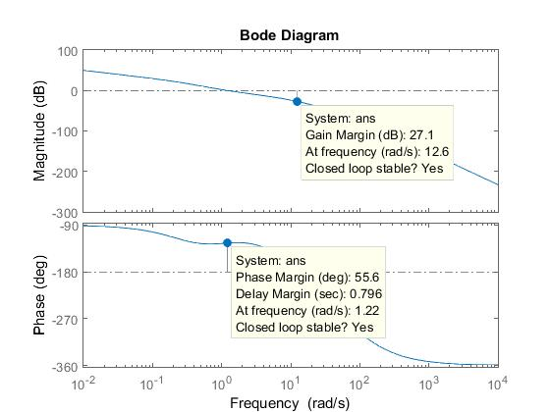

Figure 2

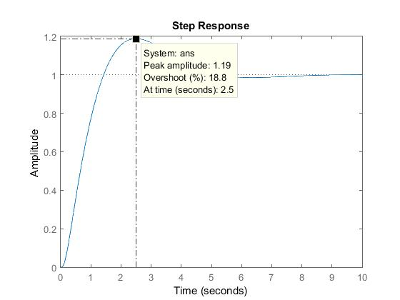

Figure 3

In the step response of the plant, the percentage overshoot is close to 20% within 10% error, which satisfies the entire requirement.

Table 1: Performance of the modified plant with lead compensator

|  |  |
| --- | --- |
| Steady state error to a unit ramp | 0.029 |
| Rise Time | 0.981s |
| Settling Time | 4.79s |
| Percentage Overshoot | 18.8% |
| Phase Margin | 55.6 |
| Gain Margin | 27.1dB |
| Bandwidth | None |
| Peak Magnitude | None |
| Resonant frequency None | None |

# **Question2**

**[35 marks] Consider again the unity feedback servo system with a plant transfer function given by:  
𝐺(𝑠) =5000/𝑠(𝑠 + .3)(𝑠 + 22)(𝑠 + 100)**

**a. Using the root locus approach, design a phase lead compensator to meet the following performance specifications:  
• The settling time resulting from a step input to be less than 4s  
• The overshoot is less than 15% Describe clearly each stage of your design. If performance specifications are not met first time try to refine the lead compensator.**

I have picked peak overshoot as 10%, with the equation below the damping ratio can be worked out.



Equation 25

Since the requirement of the settling time is 4s, so set Ts=4s to gain the nature frequency

$$Ts≅\frac{4}{ω_{n}}≤4$$

Equation 26

=0.591

$${z=ω}_{n}=1$$

$ω_{n}$ =1.69

Equation 27: Determine the natural frequency from above

$$\frac{5000k(s+1)}{s(s+0.3)(s+22)(s+100)(s+p)}$$

Equation 28: Model of compensated plant

Desired roots for new plant:

$$r1,2=-ω_{n}±jω_{n}\sqrt{1-{}^{2}}=-1±1.369j$$

Equation 29: Desired roots calculation

$$Gc\left(r1,2\right)GH\left(r1,2\right)=-1$$

Equation 30

$$θ=∠G\left(r1,2\right)GH\left(r1,2\right)=∠\frac{5000\left(r1,2+1\right)}{r1,2\left(r1,2+0.3\right)\left(r1,2+22\right)\left(r1,2+100\right)\left(r1,2+p\right)}=-180°$$

Equation 31: Determine the angle of p

$$θz=∠\left(r1+1\right)=90°$$

$$θ1=∠\left(r1\right)=\tan^{-1}{(\frac{1.369}{-1}})=-53.85 \\ θ0.3=∠\left(r1+0.3\right)=\tan^{-1}{(\frac{1.369}{-0.7}})=-62.92$$

$$θ22=∠\left(r1+22\right)=\tan^{-1}{(\frac{1.369}{21}})=3.73$$

$$θ100=∠\left(r1+100\right)=\tan^{-1}{(\frac{1.369}{99}})=0.79$$

$$90+53.85+62.92-3.73-0.79-∠(p)=-180$$

Equation 32: Calculations for each pole’s angle

$$∠(r+P)=382.25$$

Equation 33: Angle for pole P

$$tan\left(382.25\right)=\frac{1.369}{p-1}=0.409$$

Equation 34

$$P=4.35$$

Equation 35

$$\frac{s+1}{s+4.35}$$

Equation 36: Lead compensator of the calculation

However the calculated compensator’s zero is not suitable for the performance required, therefore to apply another rule, which is using the value at the left of smallest pole except 0. In this case, 0.31 was chosen instead of 1.

$$KGc\left(r1\right)G\left(r1\right)=1, K=2.87$$

Equation 37: Calculate new K for this Plant

$$\frac{s+0.31}{s+4.35}$$

Equation 38: Modified lead compensator

$$GKlead=\frac{5000k(s+0.31)}{s(s+0.3)(s+22)(s+100)(s+4.35)}$$

Equation 39: New Plant with modified compensator, k=2.87

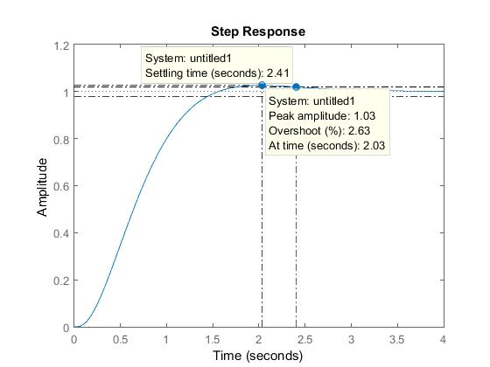

Figure 4: Peak Overshoot and settling time of new plant

From the figure 4 above, required 4s settling time is satisfied and the overshoot is merely 2.63%, which is a good result.

**b. Design a phase lag compensator in series with the lead compensator designed in a. such that the steady state error resulting from a ramp input should be no greater than 3.5% of the ramp magnitude. Describe each stage of your design. If performance specifications are not met first time, perform additional design iterations (i.e. refine the lag compensator or design additional compensators/pre-filter**). Write down the final compensated open- and closed-loop transfer functions and use MATLAB to evaluate the performance of your final design in the time and frequency domain. Use M**ATLAB to plot the response of the control system to a unit ramp, showing both system output and ramp input, and evaluate the percentage steady state error to the ramp input signal. Summarize the performance indices of your final design in a table – see Table 1 - and provide a written conclusion for your design.**

$$Ess=\lim_{s→0}{sG\left(s\right)=}\lim_{s→0}{\frac{s×2.87×5000×\left(s+0.31\right)}{s\left(s+0.3\right)\left(s+22\right)\left(s+100\right)\left(s+4.35\right)}}=1.79$$

Equation 40: The steady state error of the ramp input

In this solution, the Ess (steady state error) was chosen to 3.3% for the convenience of calculation and feasibility. Therefore the compensated Kv is rounded to 30.

$$K_{v}=\lim_{s→0}\left(\frac{5000×s×2.87×\left(s+0.31\right)×k}{s\left(s+0.3\right)\left(s+22\right)\left(s+100\right)\left(s+4.35\right)}\right)=\frac{1}{0.033}=30$$

Equation 41

$$1.55k=\frac{1}{0.033}, k=19.35$$

Equation 42

K=19.35, which does not meet the requirement in the later calculation.

$$Z=\frac{0.31}{10}=0.031$$

Equation 43

To satisfy the requirement of settling time 0.31 was chosen because it is left of the dominant pole 0.03

$$α=\frac{Kv,compensated}{Kv,uncompensated}=\frac{30}{1.79}=16.76$$

Equation 44

$$P=\frac{Z}{α}=\frac{0.031}{16.76}=0.00185$$

Equation 45

$$Klag=\frac{K(s+0.031)}{S+{1.85×10}^{-3}}$$

Equation 46

$$G*Klead*Klag*K=\frac{5000×\left(s+0.31\right)×2.87}{s\left(s+0.3\right)\left(s+22\right)\left(s+100\right)\left(s+4.35\right)}×\frac{K(s+0.031)}{S+{1.85×10}^{-3}}$$

Equation 47: Final Open-Loop Compensated Plant, where K actually is 0

And the closed-loop feedback of the plant is

$$Gc=\frac{14350×\left(s+0.031\right)(s+0.31)}{s\left(s+0.3127\right)\left(s+22.45\right)\left(s+99.98\right)\left(s+0.0316\right)(s^{2}+3.872s+6.218)}$$

Equation 48: Close Loop feedback of Plant

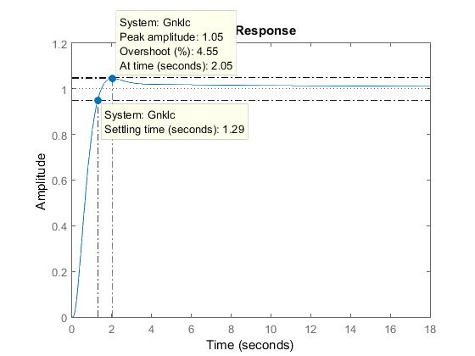

Figure 5: Step response of compensated plant

As interpreted on the diagram, the settling time is 1.29 and so within the needed 4s. The over shoot is 4.55% which also meets the requirement.

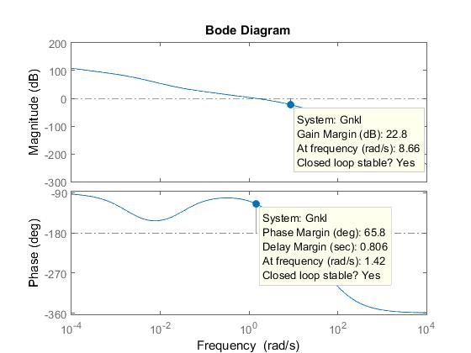

Figure 6: Bode diagram of compensated plant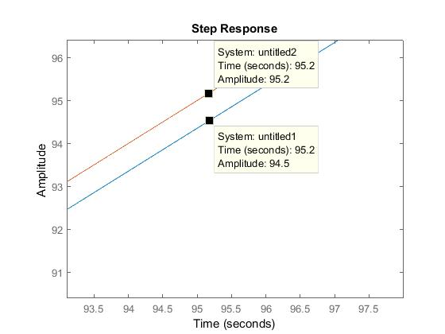

Figure 7: System output and ramp input.

The comparison of ramp input and system output shows that the steady state error meets the requirement

Table 2

|  |  |
| --- | --- |
| Steady state error to a unit ramp | 0.033 |
| Rise Time | 0.561 |
| Settling Time | 2.04 |
| Percentage Overshoot | 12.7% |
| Phase Margin | 55.8 |
| Gain Margin | 18.7dB |
| Bandwidth | None |
| Peak Magnitude | None |
| Resonant frequency None | None |

# References

Ellis, George. *Control System Design Guide*. Amsterdam: Elsevier Academic Press, 2004. Print.